Module 1: Critical Thinking Assignment

Nathan Rogers
Colorado State University Global
Course Code: CSC505
Dr. Luis Gonzalez
02/16/2025

Assignment
To get familiar with Python programming and its related Integrated Development Environment (IDE), begin by writing a simple Python script with any desired functionality. I chose to program a simple calculator with a set selection of operators. Below are the outputs from two scenarios:
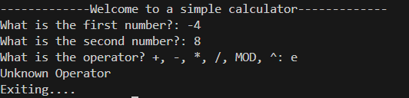
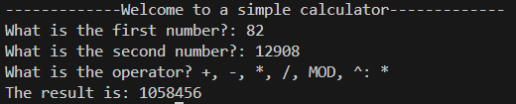
Assignment Questions
- Why does it take so long to get software finished?
Software is often times not a straightforward path. The path often doubles back, goes off in one direction and back in another the next minute. In other words, revisions, changes to the scope, and functionality changes/improvements can all happen during a project. This could be due to a shift in stakeholder requirements, market competition, timeline, or costs to complete the project increasing/budget decreasing. Software is also not usually a “finish-able” topic as there are always new functionality to add or refine. That’s why new features come in waves. Even after the completion of the scope there can still be issues that need fixed after deployment.
Another consideration is how long the business developing the software has been developing software for. A new team could take longer to develop something than a team that has been working together for a long time. Time predictions made could be off due to unforeseen conflict/issues. “Predictions are manipulations of memories. They connect our previous experiences with ideas about the future. What do we know about which memories we use and how we connect the past and future when predicting time? What has happened when a person thinks that 30 work hours is a reasonable time usage prediction? How did this person’s memories turn into a number of work hours? The simple and honest answer is that we do not know much about these issues.” (Halkjelsvik & Jørgensen, 2018).
- Why are development costs so high?
Development costs can many times be very high due to the development team needed, HR team to help govern, physical requirements such as office space, servers, licenses, and the complexity and scope of the project. Another reason, according to Hannay, “It should also help you to avoid phenomena such as the escalation of commitment to a failing course of action in general and in software development in particular. This phenomenon involves people continuing to pursue activities in the face of clear signs that the activities are not achieving the goals, due to an (often emotional) attachment to the effort already invested in the activities. Related to this are the sunk cost effect and the Concorde effect, wherein a rationale is created to continue an ostensibly failing course of action, with the argument of not wasting what has already been invested (Hannay, 2021).
- Why can't we find all errors before we give the software to our customers?
As developers, we know how the software works and unless the bug/error is included in the standard testing or the path of our development it is hard to find all issues. When giving the software to someone who is not included in the development cycle, they will find new ways to break the system/software by using the software in perhaps a way that was unintended. Customers or people outside of development don’t know what is possible and what is not as they will try and use it for their use cases. On another hand, perhaps the error lies in functionality that doesn’t properly handle one small use case that leads to an error unconsidered during the scope planning process.
- Why do we spend so much time and effort maintaining existing programs?
As developers and project managers, we need to ensure that all stakeholders are taken care of. There may be a small number of stakeholders that use certain legacy software over the new software due to limitations of current systems. Those stakeholders or customers are not any less important than stakeholders that adopt the new software. They still need the software they currently must continue functioning. Perhaps over time they may adopt the new software, however if you write them off and end support, they may look elsewhere when they do decide to upgrade in which case the business lost an existing customer.
- Why do we continue to have difficulty in measuring progress, as software is being developed and maintained?
If using the Agile methodology, development of an application can swap quickly back and forth between functionality development due to evolving stakeholder demand and importance. Using a Gantt chart can help keep track visually, however if changes to the initial scope or any changes to functionality are happening quickly and the document isn’t being updated quickly enough, it may be hard to judge the progress midway through development.
References
Halkjelsvik, T., & Jørgensen, M. (2018). Time predictions: Understanding and avoiding unrealism in project planning and Everyday Life. Springer.
Hannay, J. E. (2021). Benefit/Cost-Driven Software Development : With Benefit Points and Size Points. Springer International Publishing.
Pressman, R. S., & Maxim, B. R. (2020). Software engineering: A practitioner’s approach. McGraw-Hill Education.

